# **Ionic vs. Covalent (Molecular) Compounds**

**Introduction:**

Ionic compounds are formed from ionic bonds. An ionic bond is one in which electrons are transferred from one atom to another. This results in one atom becoming a positive ion (cation) and one atom becoming a negative ion (anion). Covalent compounds (molecular) are formed from covalent bonds. A covalent bond is one in which electrons are shared between two atoms. This results in neither atom having a net positive or negative charge. The type of bond within a compound influences the types of properties that the substance will have.

**Ionic Compounds**

Ionic compounds typically are solid at room temperature. They form a crystal lattice structure with more than one formula unit present (see figure A). Notice that the positive charges and negative charges alternate. This results in a very strong attractive force between all of the ions of the crystal. Because of the strong forces between ions, ionic compounds tend to have very high melting points.

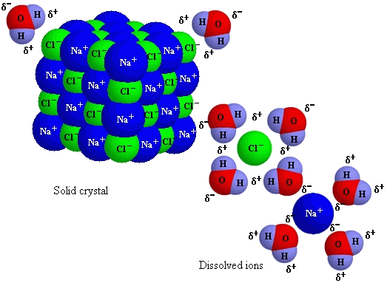

Figure A.

These types of compounds tend to dissolve in water. When the water molecules surround the ionic crystal, the positive and negative ions of the ionic compound are able to separate and move freely throughout the water. In fact, because water is considered to be a polar molecule (remember polarization?), the water is able to surround each positive and negative ion. Because the electrons are free to move around in the water, this results in a solution (homogeneous mixture) being able to conduct electricity. Electrons can travel from the ions to the ion or to the water freely. This differs from the ionic crystal because the ions are now free to move in the solution.

**Covalent compounds (molecular compounds)**

Covalent compounds are typically liquids or gases at room temperature, although the more complex and larger the molecule, the greater the chance that it could exist as a solid. Methane (CH4) is a gas at room temperature while paraffin wax (C25H52) is a solid at room temperature. One thing is common between these two molecules: they melt easily and at fairly low temperatures. These compounds do not have positive and negative charges present, so they do not form solid crystals in the same manner. See figure C. Notice that there is not a regular pattern of positive and negative particles like an ionic compound.

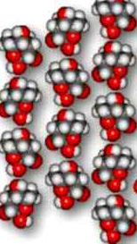 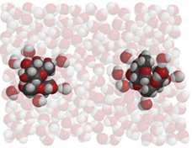

Figure C

Some molecules dissolve in water and some do not. This depends on some internal properties of the molecule. The dissolving process is a bit different as well, because there are no ions to be surrounded by water. However, if the molecule is polar, like water, the water can surround the molecule. These types of molecules will dissolve in water. Notice that dissolving molecular compounds only separates one molecule from another and does not break apart the molecule itself. Some molecules will not dissolve in water because they are not polar (like oil or wax). These molecules would not be surrounded by water molecules since there are no particle charges to attract.

Because there are no ions to transfer electrons, covalent compounds do not conduct electricity. Pure water, recall, did not conduct electricity as a covalent molecule. The only way for water to conduct electricity is for some ions to be dissolved in it (as in tap water)